**Changes added:**

When fighting the final boss, the final boss can revive and gain a ultimate ability. The player, at the same time, gain the ability to transform into a stronger form, with a new set of skills and animations.

I do not plan on using socket, but two players can control 2 characters on the same keyboard in the multiplayer battleground.

A customizable map function is also added to the game, where the player can create, style, and delete platforms on a grid by leftclicking the mouse and pressing numbers 1,2,3,4.

A scoreboard is added. It’s stored in a text file and shown on the ending screen of Luffy’s Journey.

**Previous Description:**

Project Description:

The name of my project is “One Piece Journey”. This is a fighting game based on the anime One Piece that features a story mode of Luffy fighting against bosses as well as multiplayer combat.

Competitive Analysis:

My game is similar to super smash bros, in that I will have 2 or more players fighting in a map, and each character has a set of skills. However, my game is different in that the characters will have a lot more cool skills than Smash. Also, I plan on having a scene of characters using ultimate abilities, where the fighting scene switches to video clips of One Piece anime.

Structural Plan:

I will have a main class running the main loop of the game. I will have a character class, a platform class, and a projectile class. Each character will be a subclass of character, where they have a diverse set of abilities.

Algorithmic Plan:

I plan on using pygame for this project, especially to tackle the loading of sprites as well as pixel perfect collision. I plan on using socket for multiplayer mode and implementing AI for fighting against computer.

In specific, I plan on making functions of each characters abilities and using a lot of boolean variables to check whether they are standing, walking, jumping, defending, attacking, being hit, or dead. Different boolean variables lead to sprites of different motions loaded.

Timeline Plan:

I plan on figuring out basics by TP1, implementing socket by TP2, and adding more features, storyline, as well as AI by the end.

Version Control Plan:

I will store files of different stages I’m at in my project in separate folders. This way I can see how I progressed, and I can go back to any version when necessary.

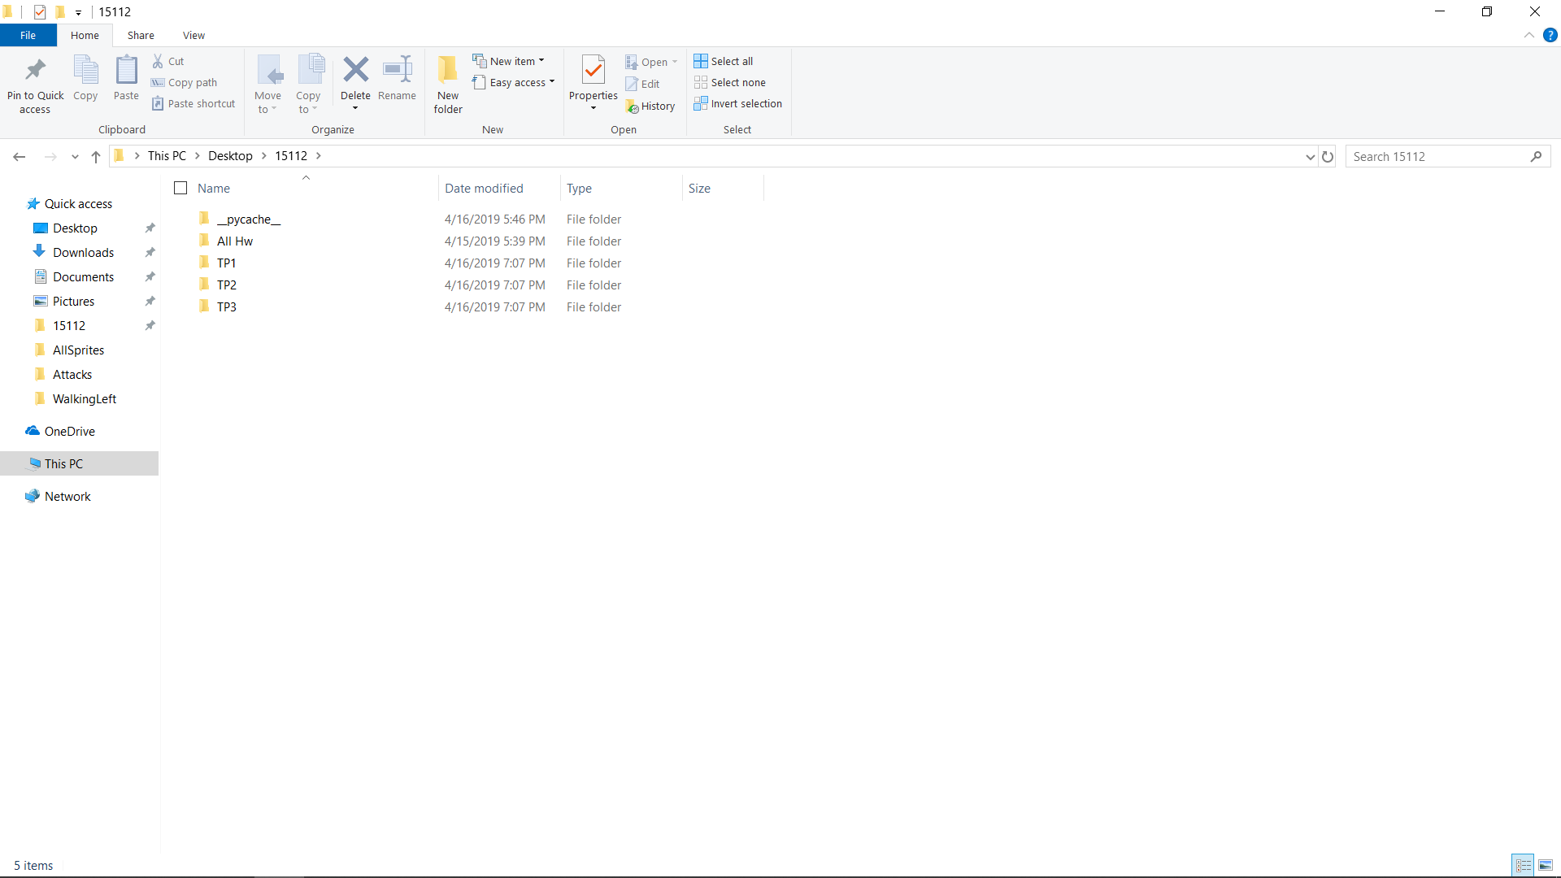

Module List:

I plan on using pygame and socket.